

Proteus Automation System

Network Proteus User Manual
Date
Original Date: | 020122 | Document Version | 0.1
Last Revision Date: | 020122
 |  | Author Information
Product Name: | Proteus Automation | Author: | Kavitha Patchamalai
 |  | Title: | Product Management
 |  | E-mail: | experis.automation@dell.com
  - SECURITY WARNING
The information contained herein is proprietary to Dell Inc. and must not be disclosed to non-Dell personnel. The recipient of this document, by its retention and use, agrees to protect the information contained herein.
Readers are advised that this project may be subject to the terms of a non-disclosure agreement.

DO NOT DISCLOSE ANY OF THIS INFORMATION WITHOUT OBTAINING PERMISSION FROM THE MANAGEMENT RESPONSIBLE FOR THIS DOCUMENT.

Document Revision History
The revision history shows the history for this Product Design Document and provides descriptions of changes made.

Date | Version | Section/Page | Update Description | Contact Name
020122 | 1.0 | All | Initial Draft | April Jewell

Contributors
The content of this document has been authored with the combined input of the following group of key individuals.
Name | Role | Area
Ashwini Kalyanpur | UI Front End Developer | India

Document Approval History
The section tracks the review and approval of this Product Design Document.
Name | Email | Role | Responsibility
April Jewell | April_Jewell@Dellteam.com | Project Manager | Approver

Contents
Document Revision History I
Contributors I
Document Approval History I
Network Proteus 3
Log In 3
NMES001 UI 4
Create Baseline 4
Compare Baseline 5
Device Compliance 6
Push Baseline 7
Log Out 10

Network Proteus
The Network Proteus application automates various tasks in Load balancing, Networking, and DNS administration that are manually handled by system engineers/administrators with minimal levels of automation.
You can perform the following tasks in the NMES001 modules:
Feature Name | Tasks
Create Baseline | Create baseline entering new SNMP configuration details
Compare Baseline | Compare a current configuration version with a previous/any version
Device Compliance | Identify non-compliant devices
Push Baseline | Push baseline configuration

Log In
Use your Dell email ID and password to log into Network Proteus. To separate the duties of individuals and to reduce the risk of malevolent activity without collusion, each module access is based on user roles assigned by the Dell System Administrator.
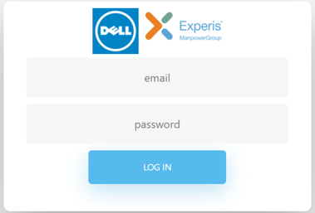

NMES001 UI
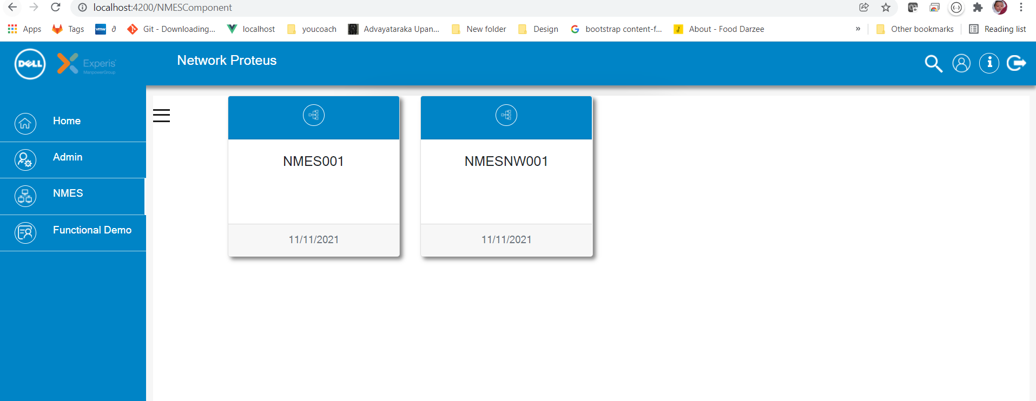
There are three modules in NMES001:
- Create Baseline
- Compare Baseline
- Device Compliance
- Push Baseline
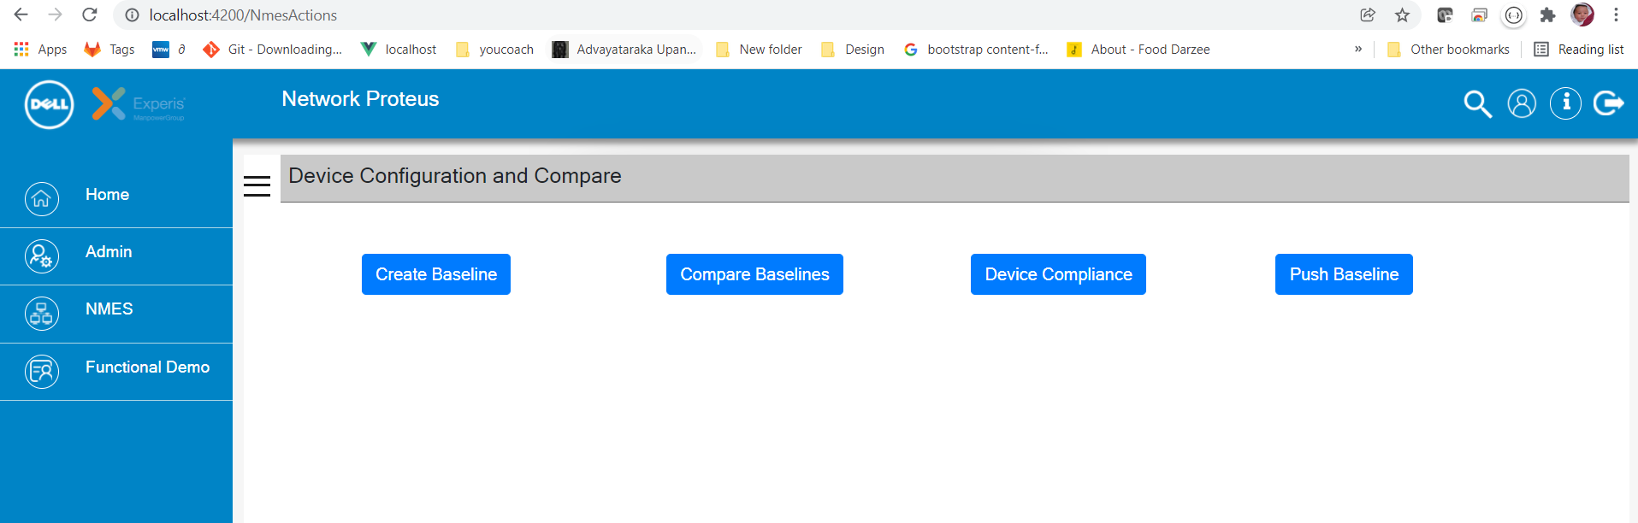

Create Baseline
You can create baseline entering new SNMP configuration details:
- Select the name of the group, IP Address and then select subset mask and read write (RW):
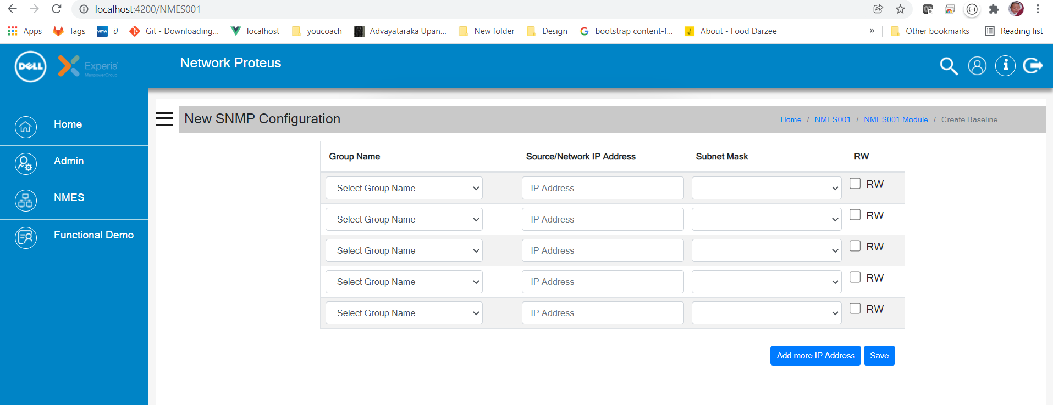
- Click Save or Add more IP address to include 5 more rows.
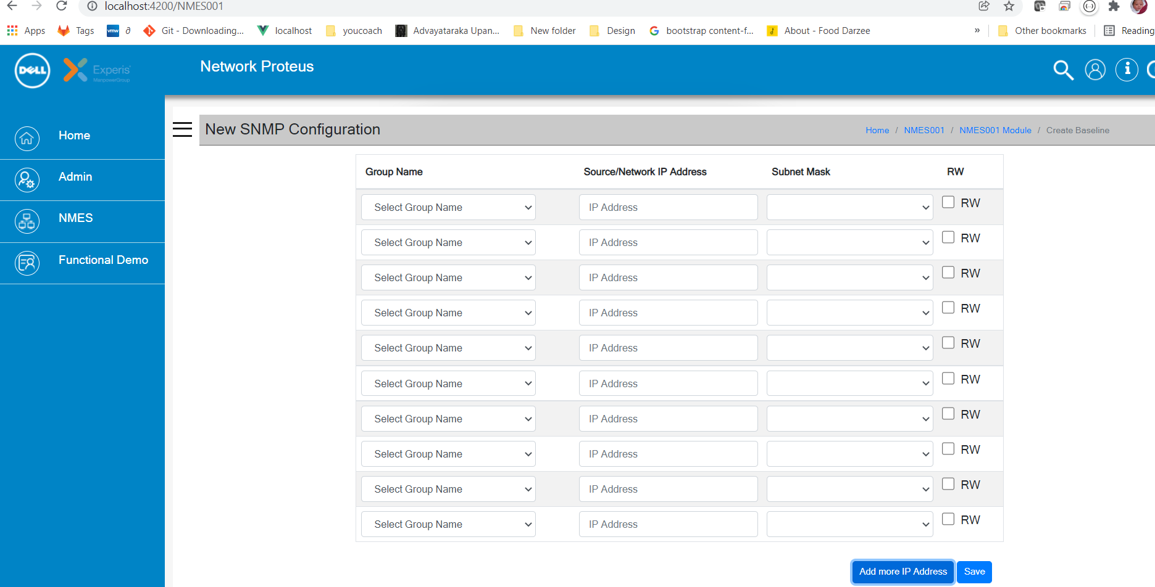
- Click Save

Compare Baseline
You can compare a current configuration version with a previous/any version:
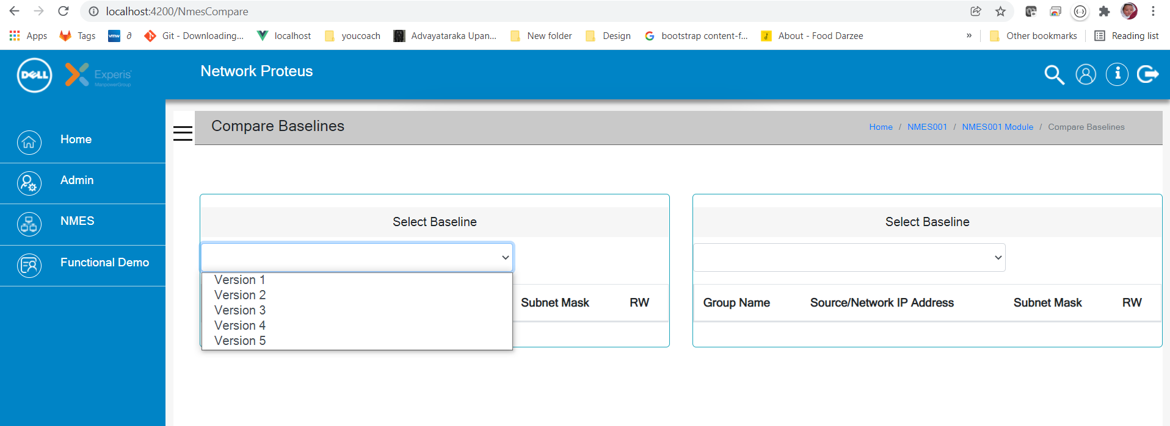
- Select the baseline versions to compare. Network Proteus displays the baseline version comparison screen.

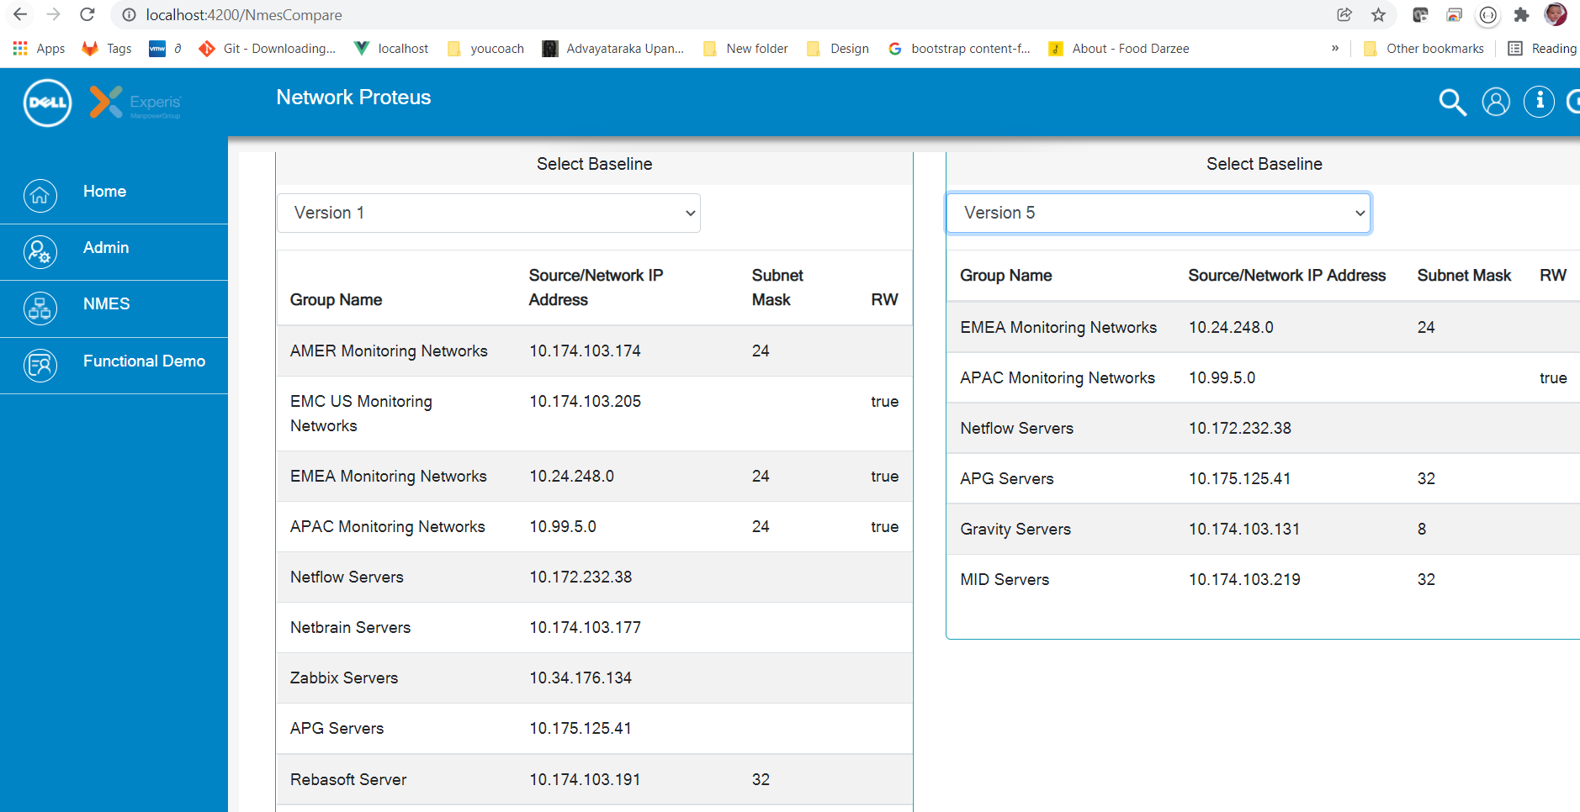

Device Compliance
You can identify non-compliant devices:
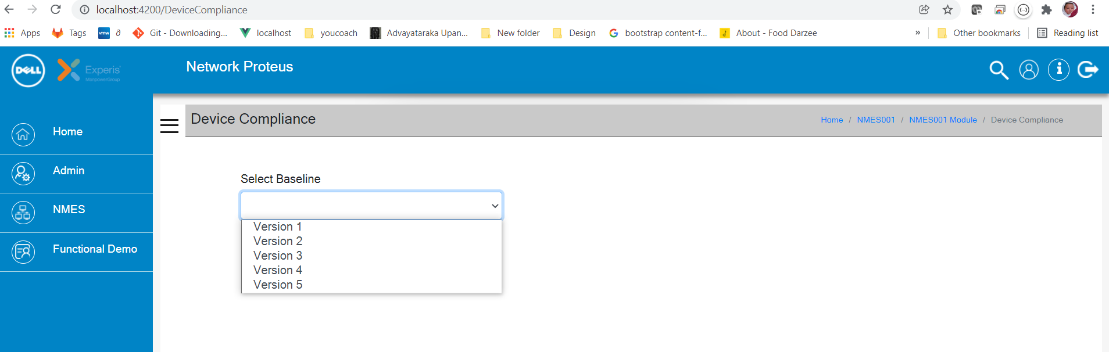
- Select Baseline.
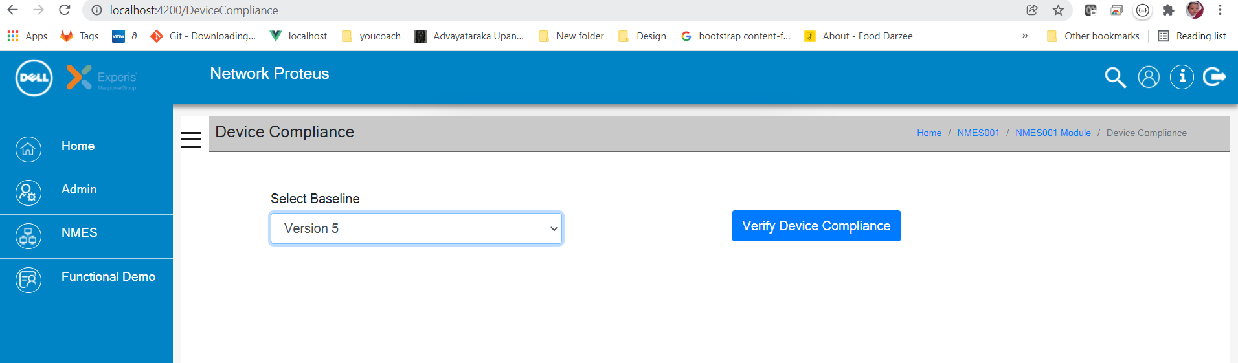
- Click Verify Device Compliance to verify the device compliance based on the selected base line. Network Proteus displays the Device Compliance screen:
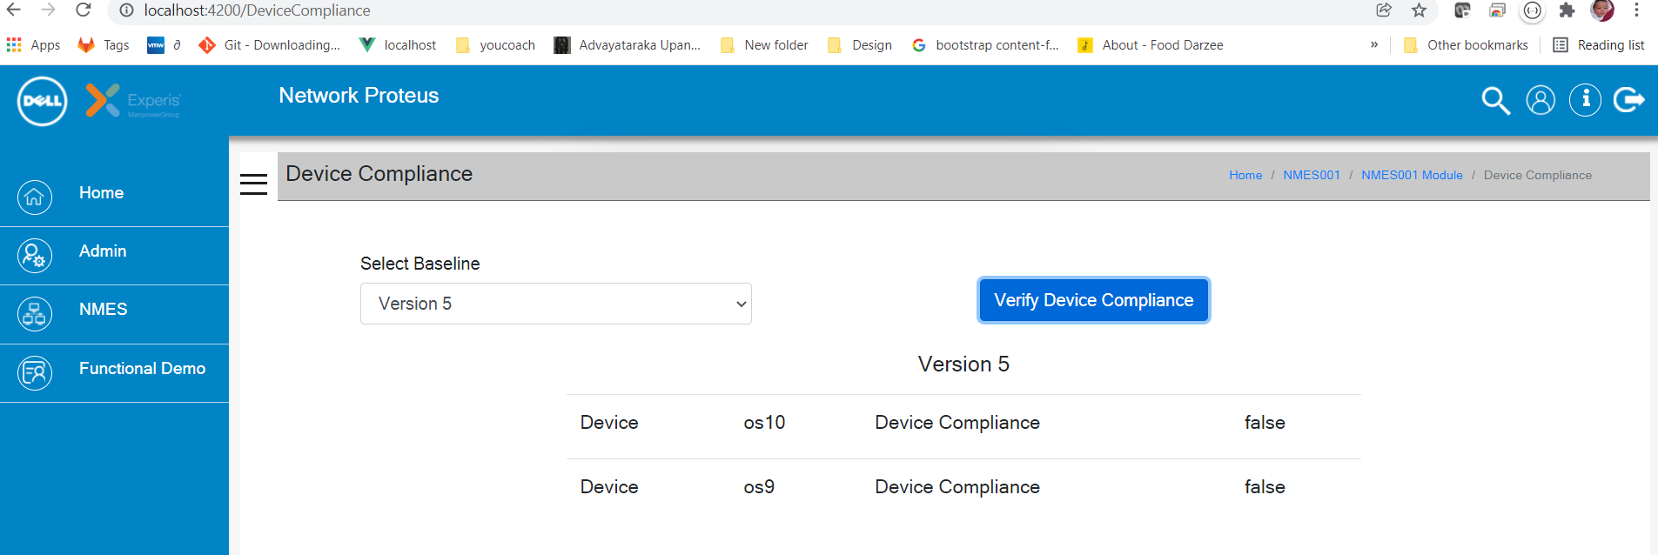

Push Baseline
You can push baseline configuration:
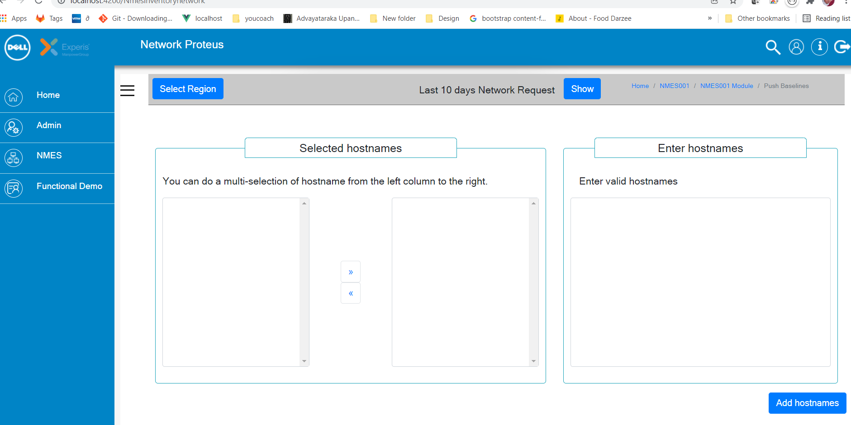
- Click Select Region to select the location(s) for uploading the Hostnames.
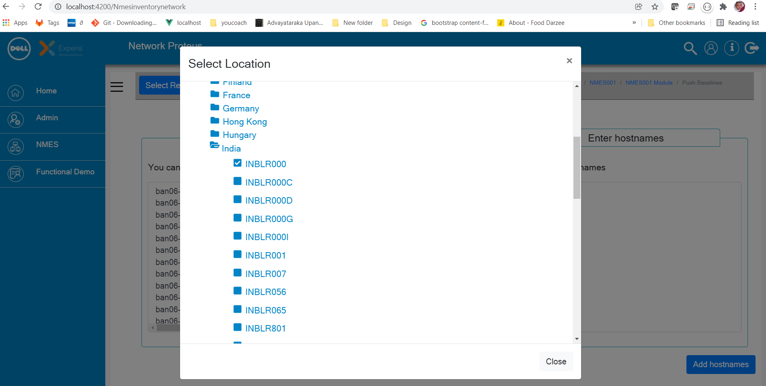
- You can select multiple devices from multiple locations.
- Enter the hostnames that belong to different OS types. Network Proteus has the capability to:
  - Identify and categorize hostnames based on the OS types.
  - Identify the invalid hostnames
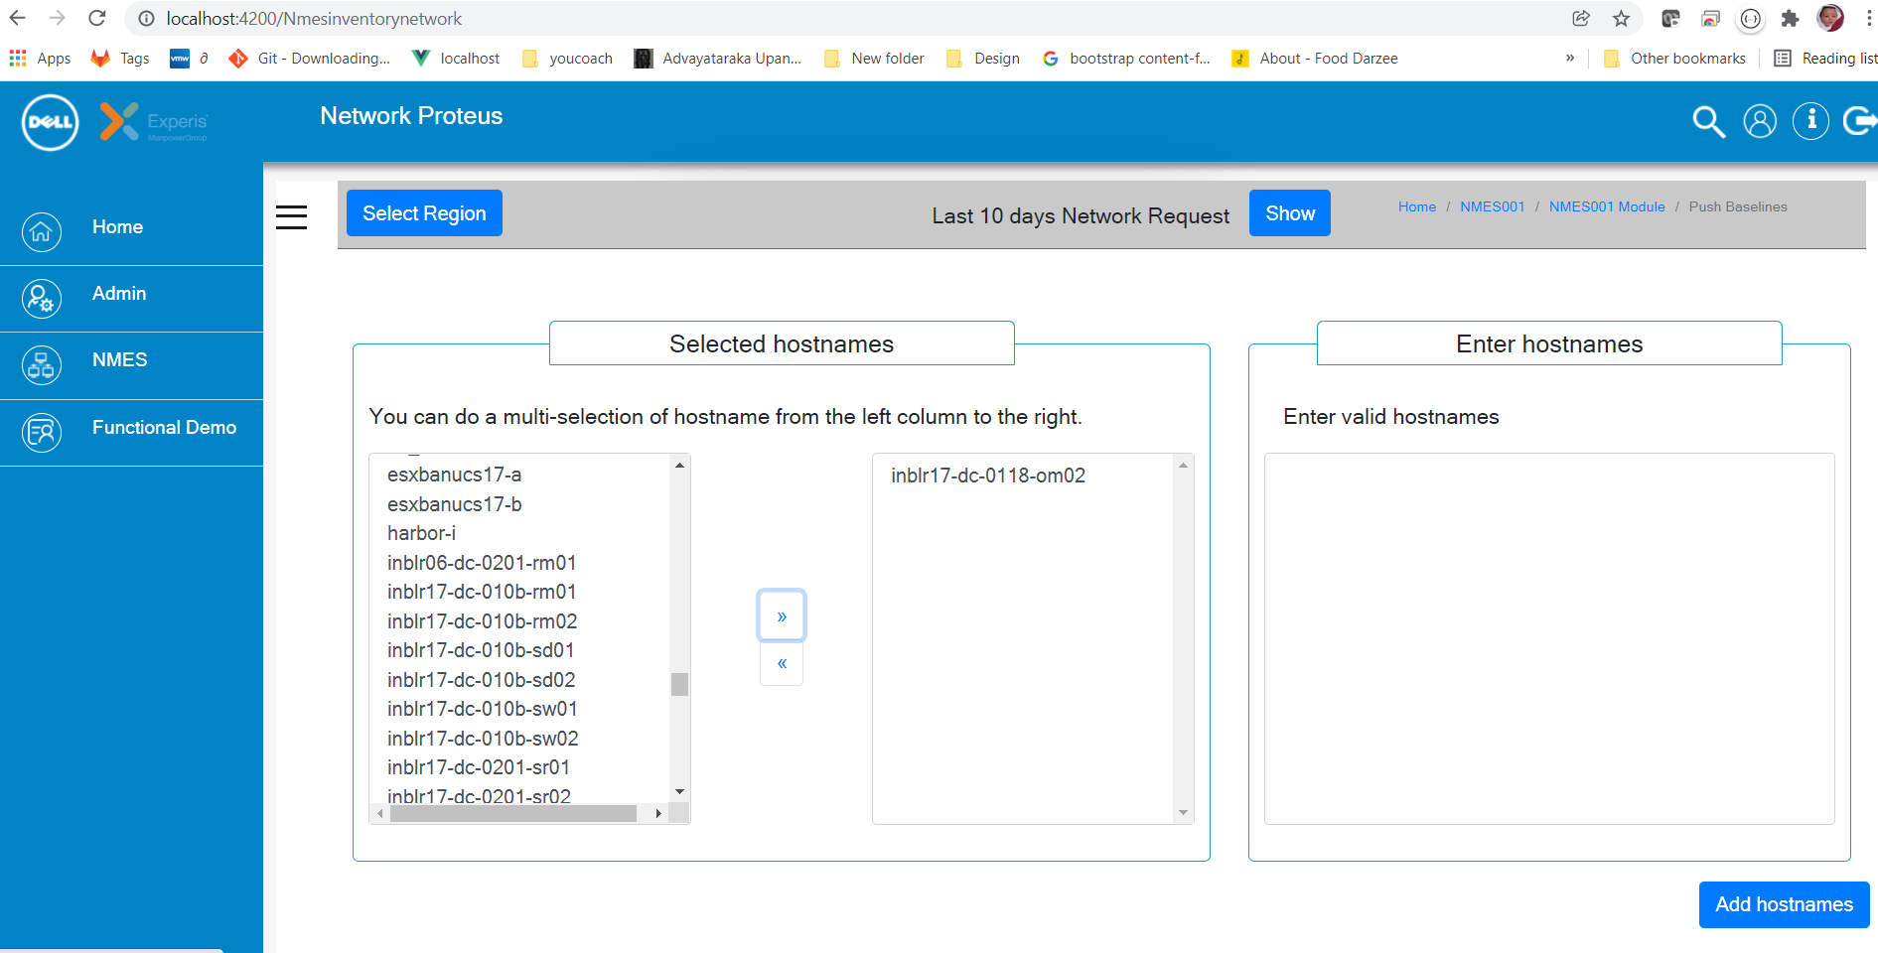
- Click Add Host Names. Network Proteus displays the Create Pipeline window:
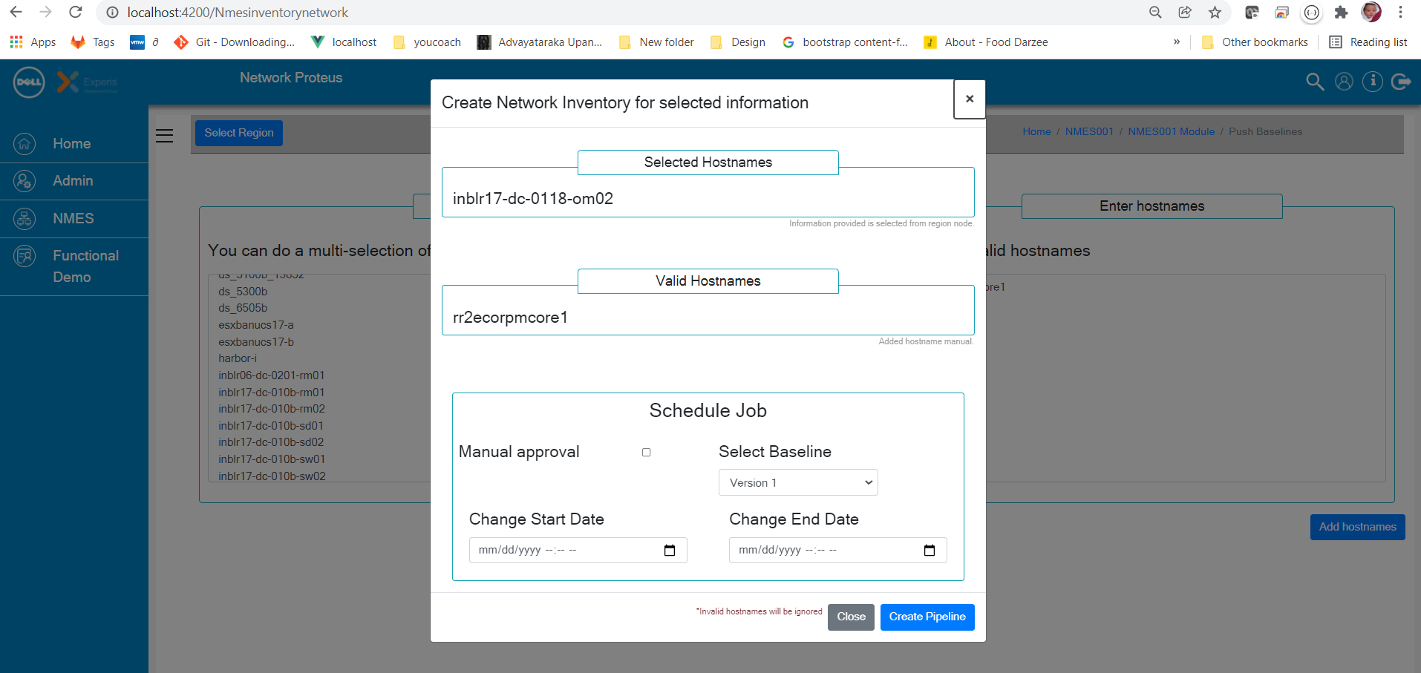
- You can click Manual approval and schedule the change entering start and end date.
- Click Create Pipeline. Network Proteus triggers the CI/CD pipeline:
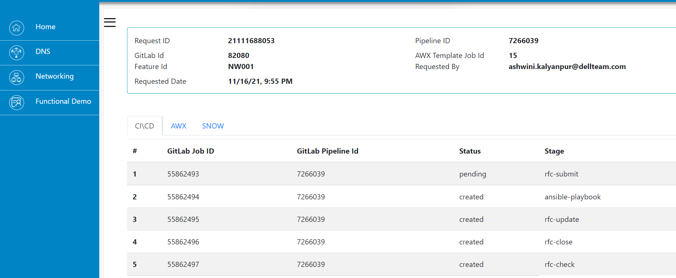
- Network proteus schedules the change and executes the change in AWX:
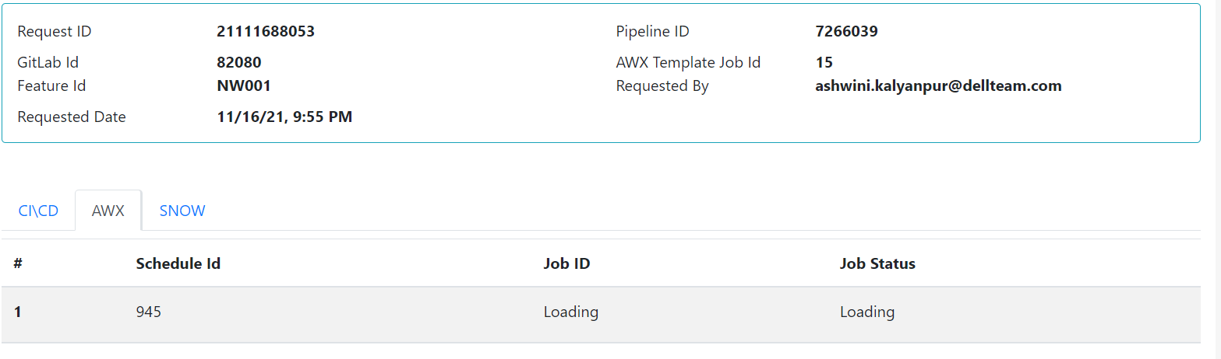
- Network Proteus creates the change ticket in SNOW:
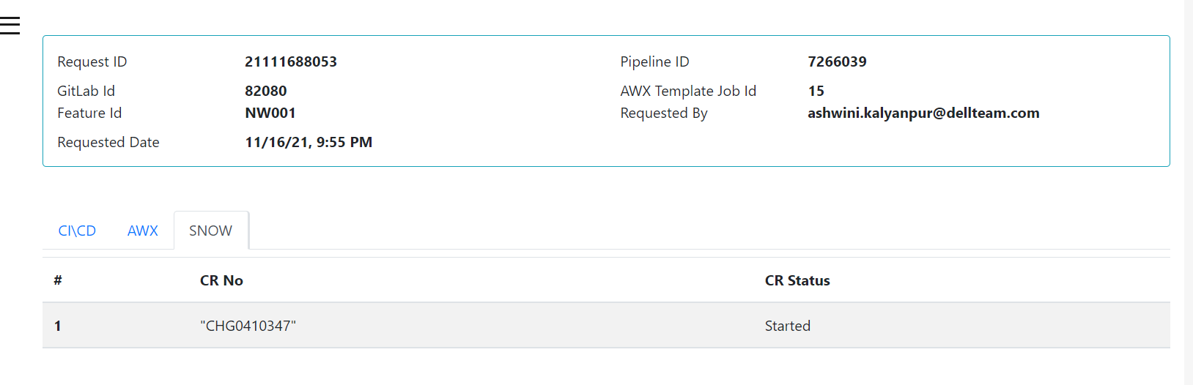
- Network Proteus provides the option to close the ticket or roll back to original configuration. 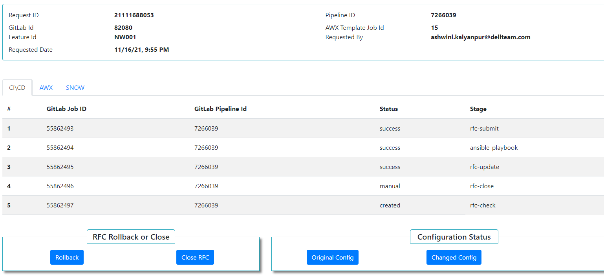
- The user can download and view these configuration files:
  - Original Configuration
  - Changed Configuration
  - Rolled Back Configuration
*A separate Rollback ID (AWX Job ID) will be generated for Rollback operation.

Log Out
To log out of Network Proteus, click icon on the top right corner of the main screen.
